Challenge -05
Objective
The objective of this task was to understand and implement AWS Lambda, API Gateway, and AWS Key Management Service (KMS). These services are commonly used in serverless architectures to build secure, scalable, and cost-effective applications without managing servers.

1. AWS Lambda
Concept
AWS Lambda Documentation
AWS Lambda is a serverless compute service that runs your code without managing servers.
Use Cases
- Backend APIs
- File processing
- Automation
- Scheduled tasks
- Event-driven applications

Hands-On Implementation
Step 1: Create Lambda Function
- AWS Console → Lambda
- Click Create Function
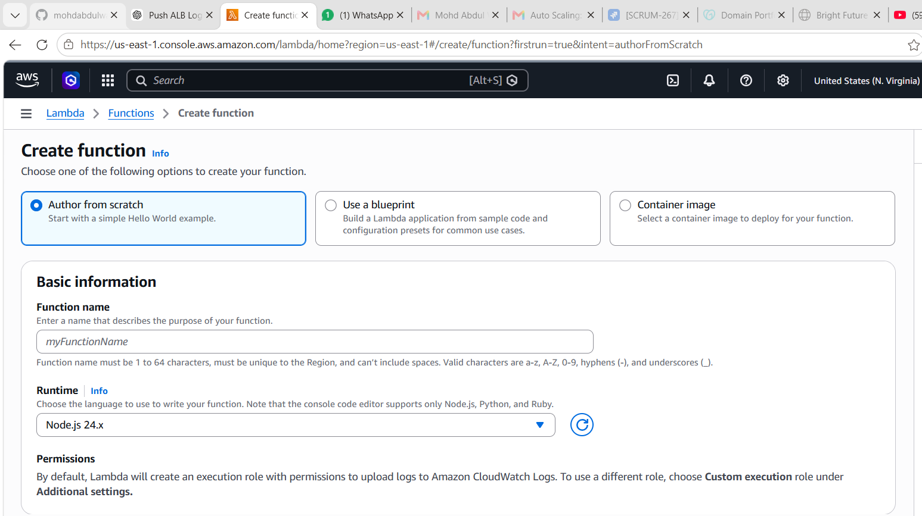
- Author from scratch
- Function name:
HelloWorldFunction
- Runtime:
Python 3.13
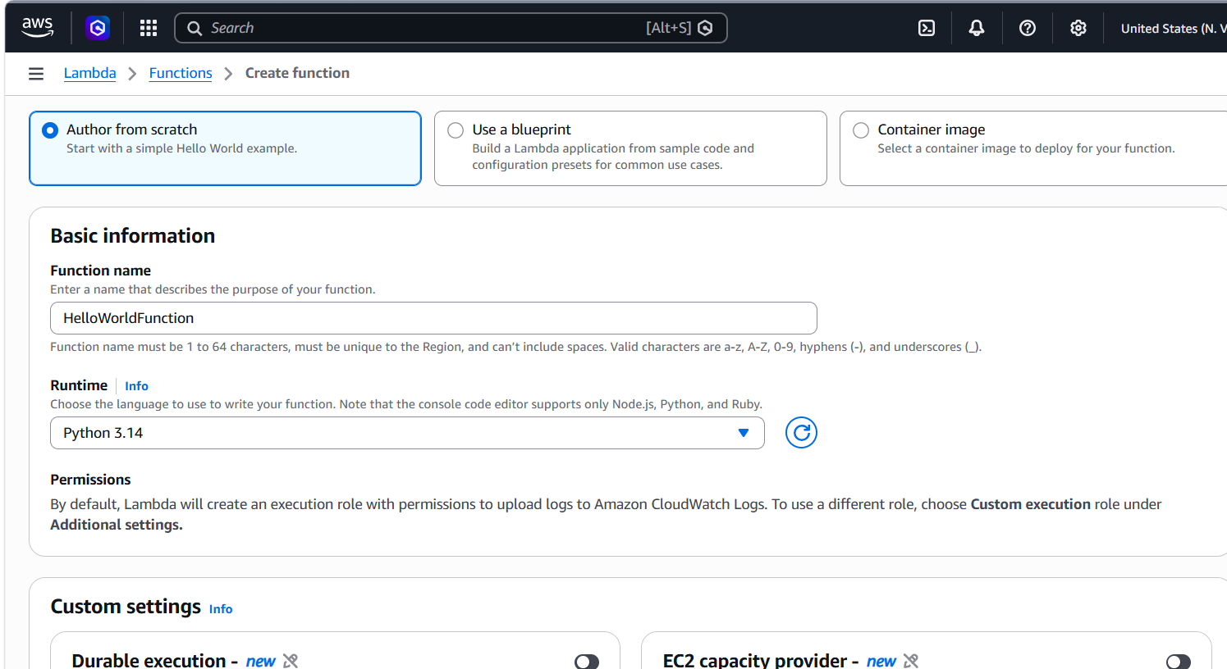
- Create Function
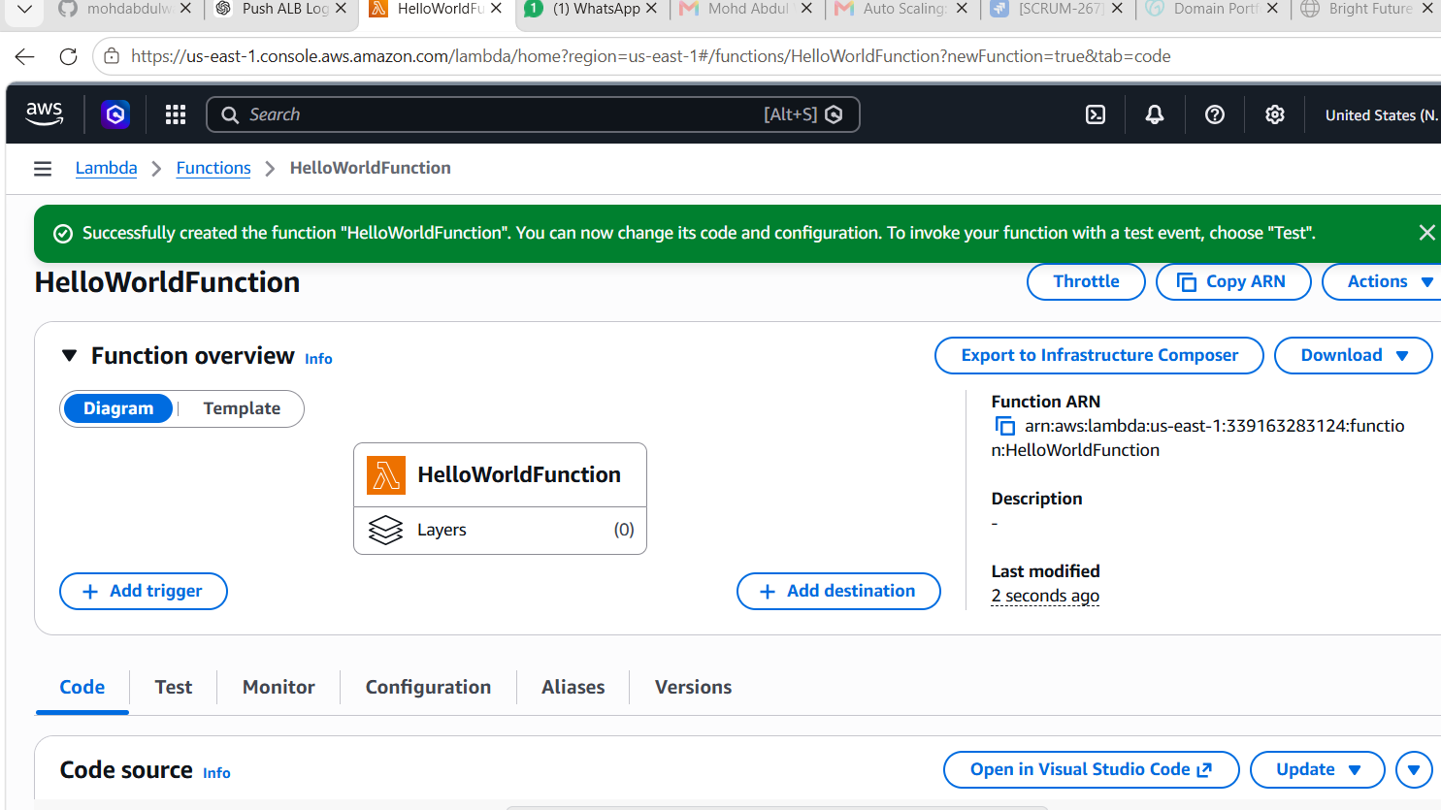

Step 2: Add Code
Replace existing code:
def lambda_handler(event, context):
return {
'statusCode': 200,
'body': 'Hello from Wasif'
}
Click Deploy
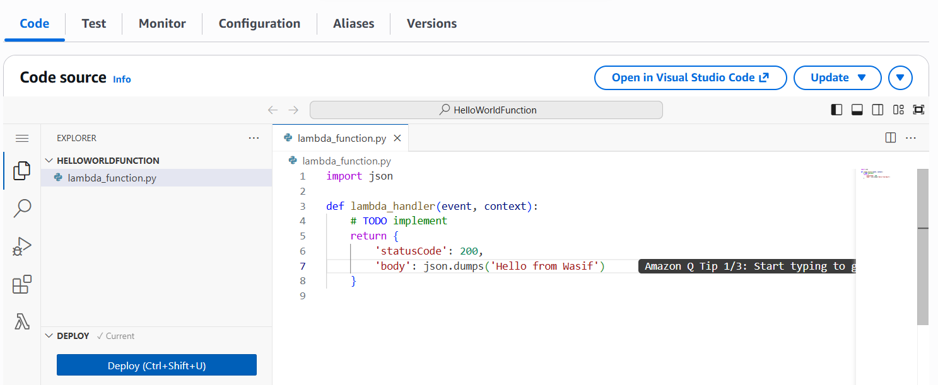

Step 3: Test Lambda
- Click Test
- Create Test Event
- Save
- Run Test
Expected Output:
{
"statusCode": 200,
"body": "Hello from Wasif"
}
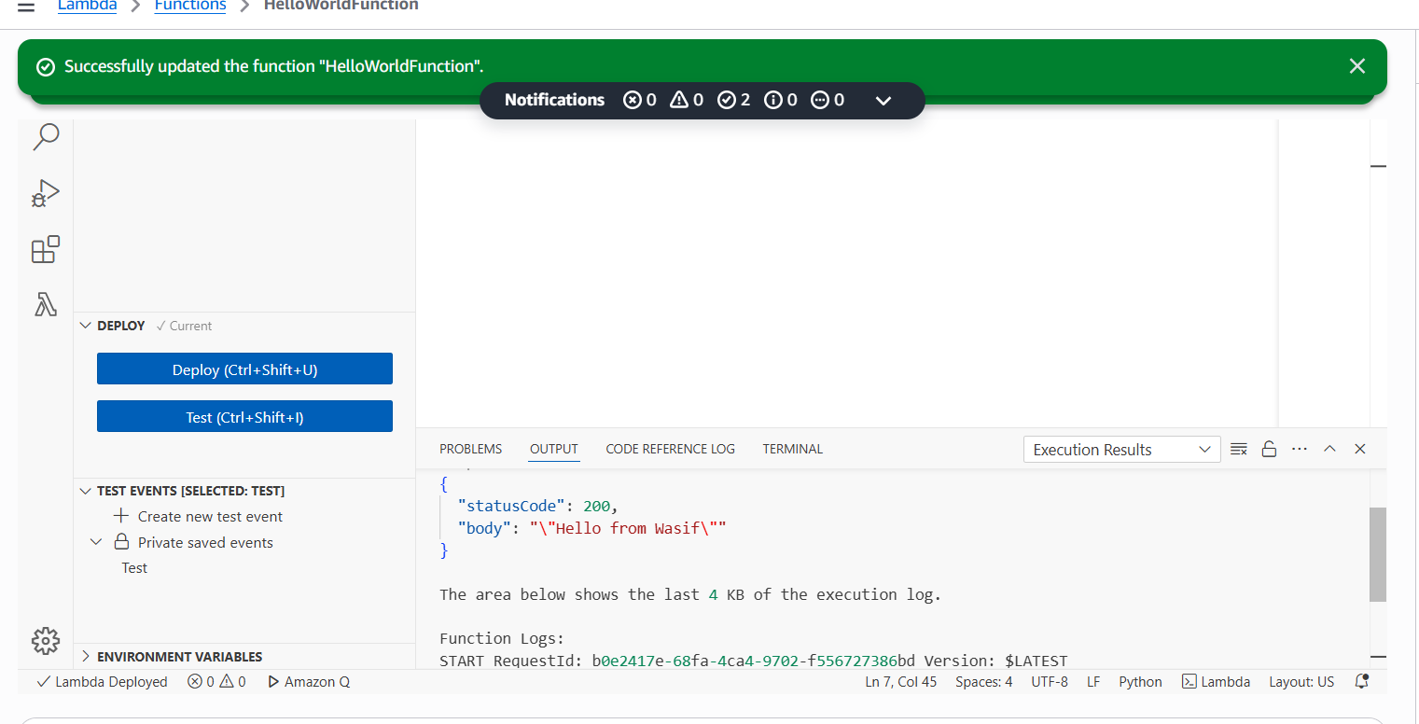

2. AWS API Gateway
Concept
Amazon API Gateway Documentation
API Gateway allows applications to expose REST APIs and connect them to backend services like Lambda.
Use Cases
- REST APIs
- Mobile Backends
- Serverless Applications

Hands-On Implementation
Step 1: Create API

- API Gateway
- Create API
- REST API
- Build
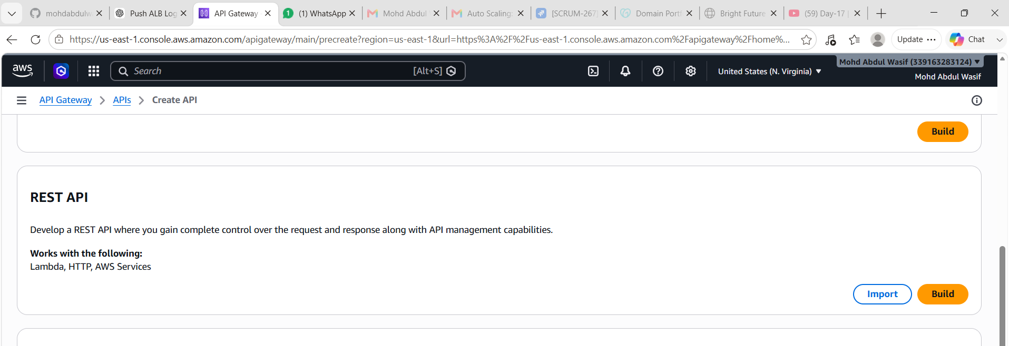

Step 2: Configure API
API Name:
LambdaAPI
Create API

Step 3: Create Resource
Resource Name:
Hello
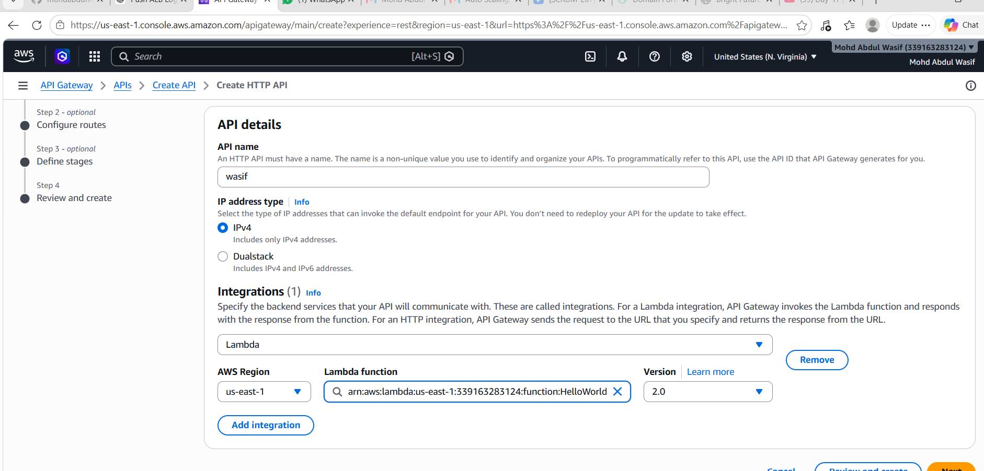
Resource Path:
/hello

Step 4: Create Method
Create Method:
GET
Integration Type:
Lambda Function
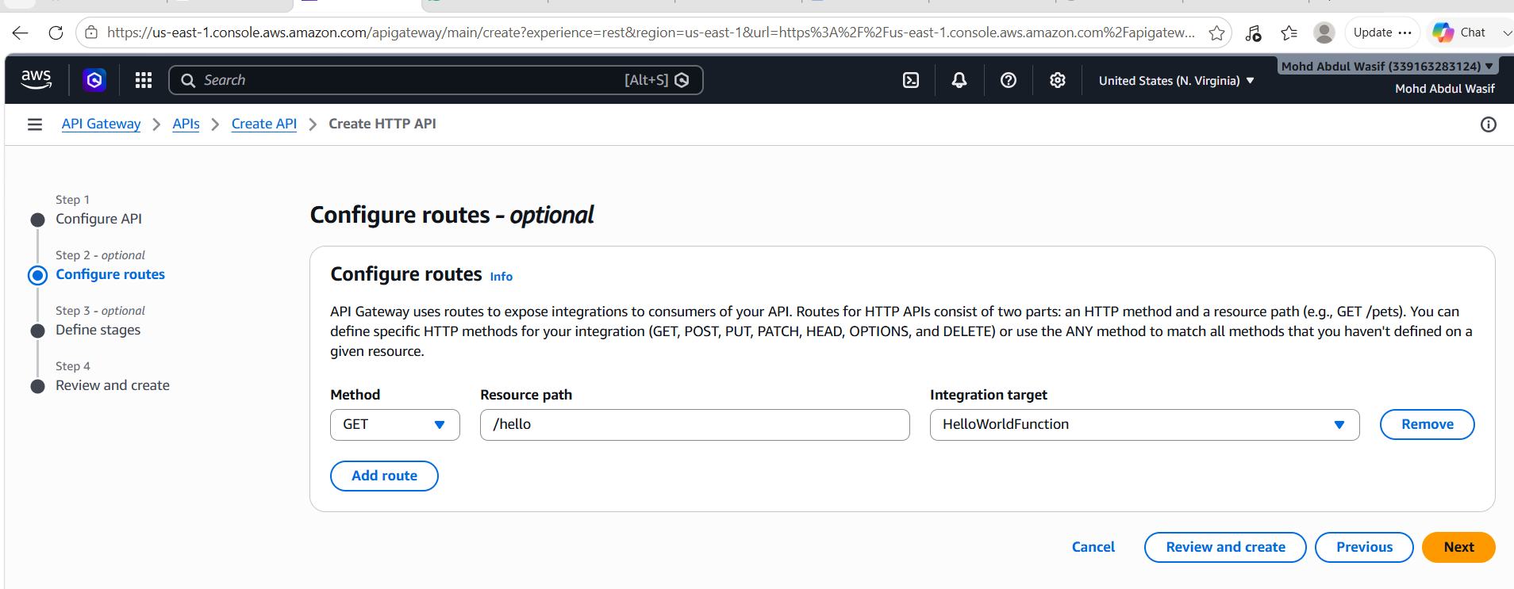
Select:
HelloWorldFunction

Step 5: Deploy API
Actions → Deploy API
Stage Name:
dev
Deploy

Step 6: Test API
Copy Invoke URL
Example:
https://abc123.execute-api.us-east-1.amazonaws.com/dev/hello
Open in browser.
Expected:
Hello from Wasif
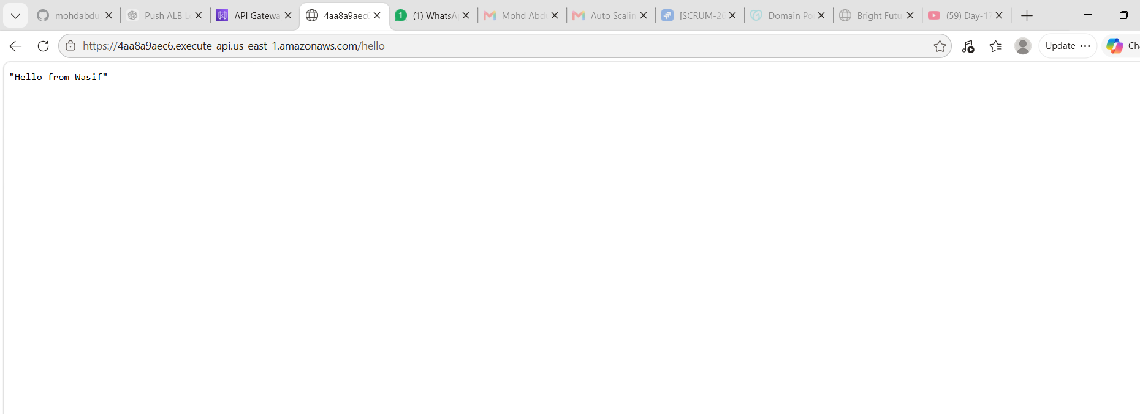
3. AWS KMS
Concept
AWS KMS Documentation
AWS KMS manages encryption keys securely.
Use Cases
- Encrypt S3 Objects
- Encrypt EBS Volumes
- Encrypt RDS Databases
- Encrypt Secrets

Hands-On Implementation
Step 1: Create KMS Key
- KMS Console
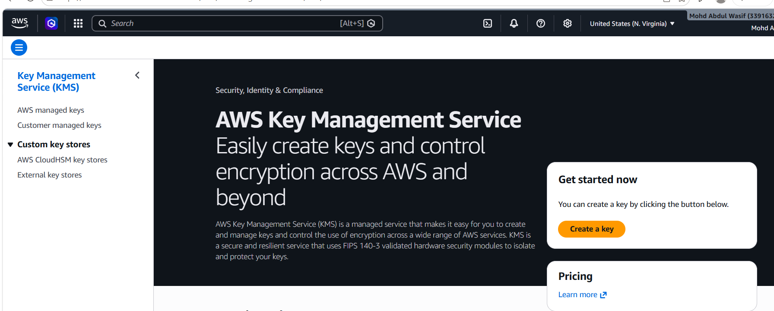
- Customer Managed Keys
- Create Key
Configuration:
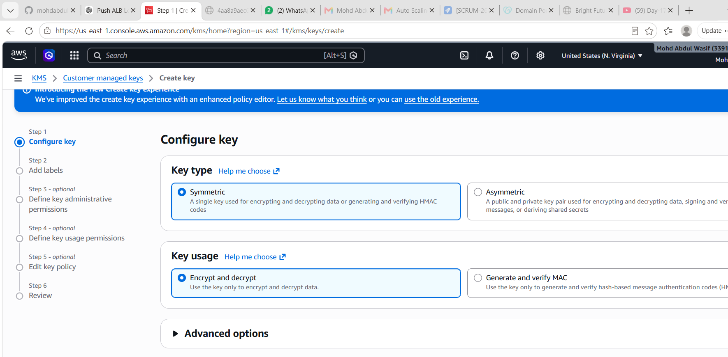
Symmetric
Encrypt and Decrypt

Step 2: Key Alias
Example:
my-kms-key
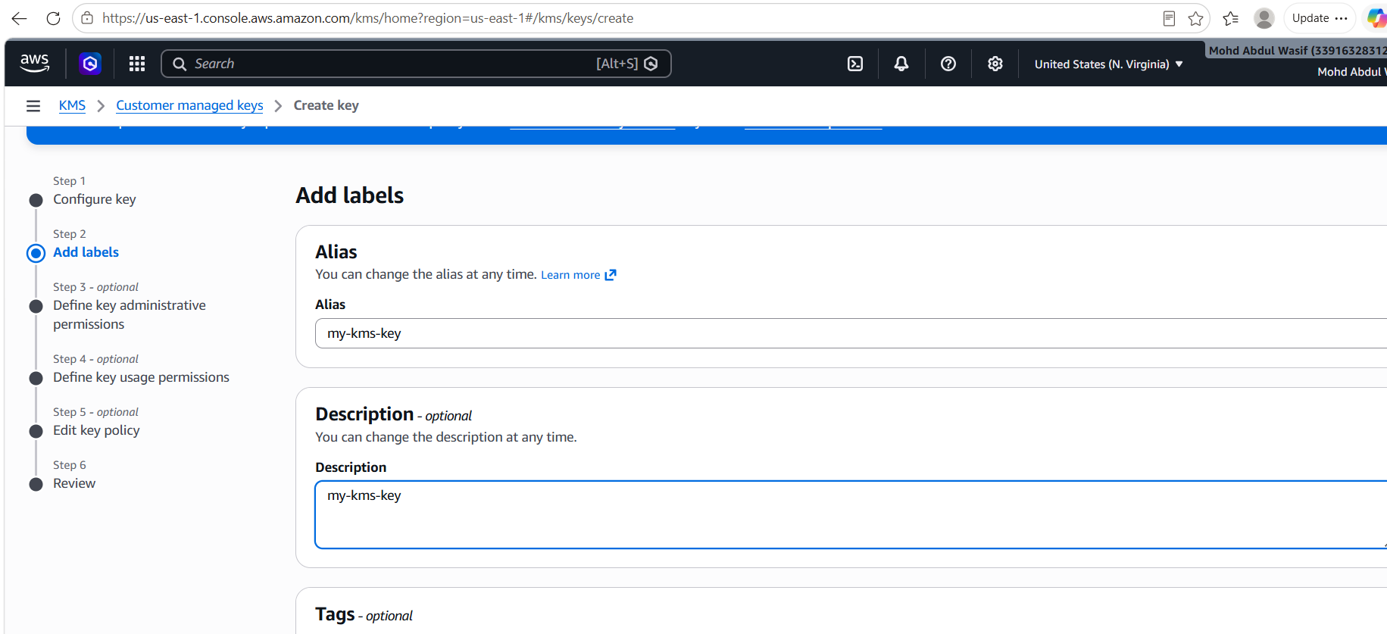

Step 3: Key Administrators
Select your IAM user
Next → Finish

Step 4: Encrypt Text
KMS → Keys → my-kms-key
Cryptographic Operations
Plain Text:
Hello AWS KMS
Encrypt
Copy Cipher Text

Step 5: Decrypt Text
Paste Cipher Text
Click Decrypt
Expected:
Hello AWS KMS
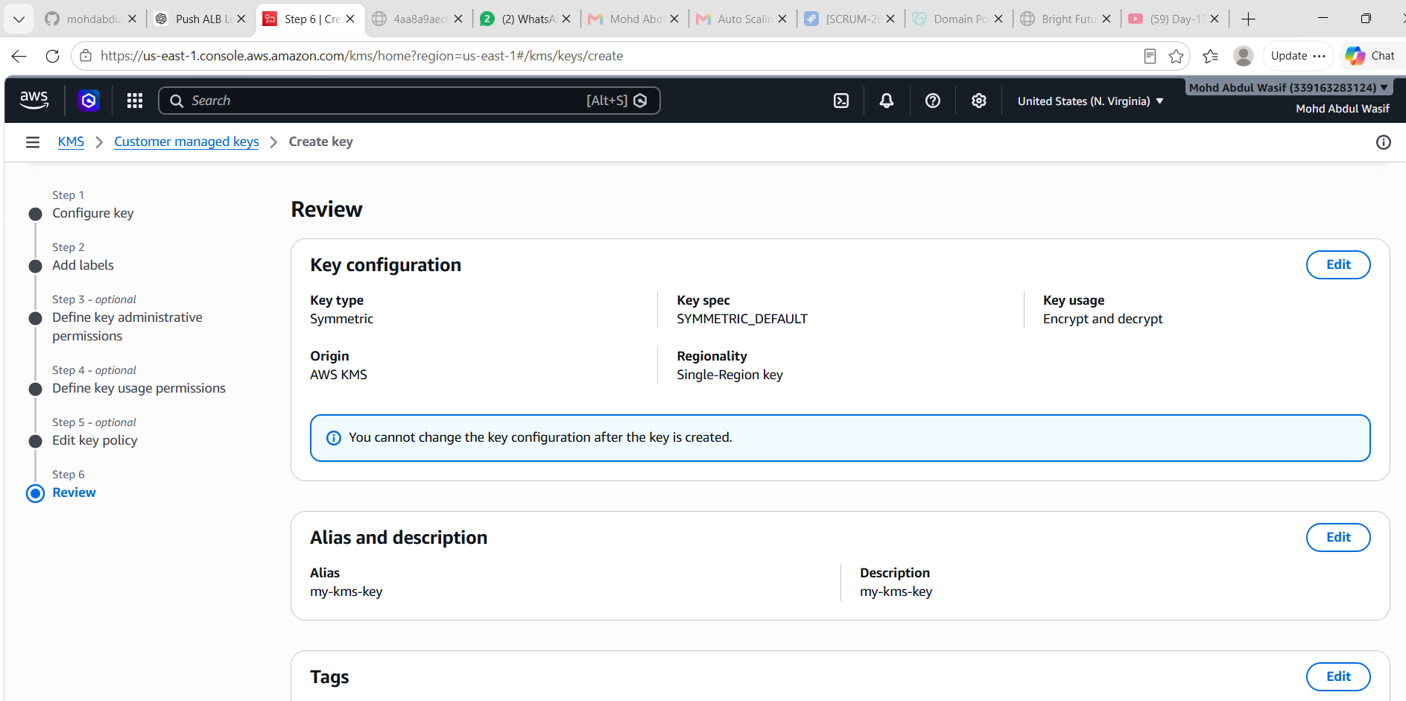
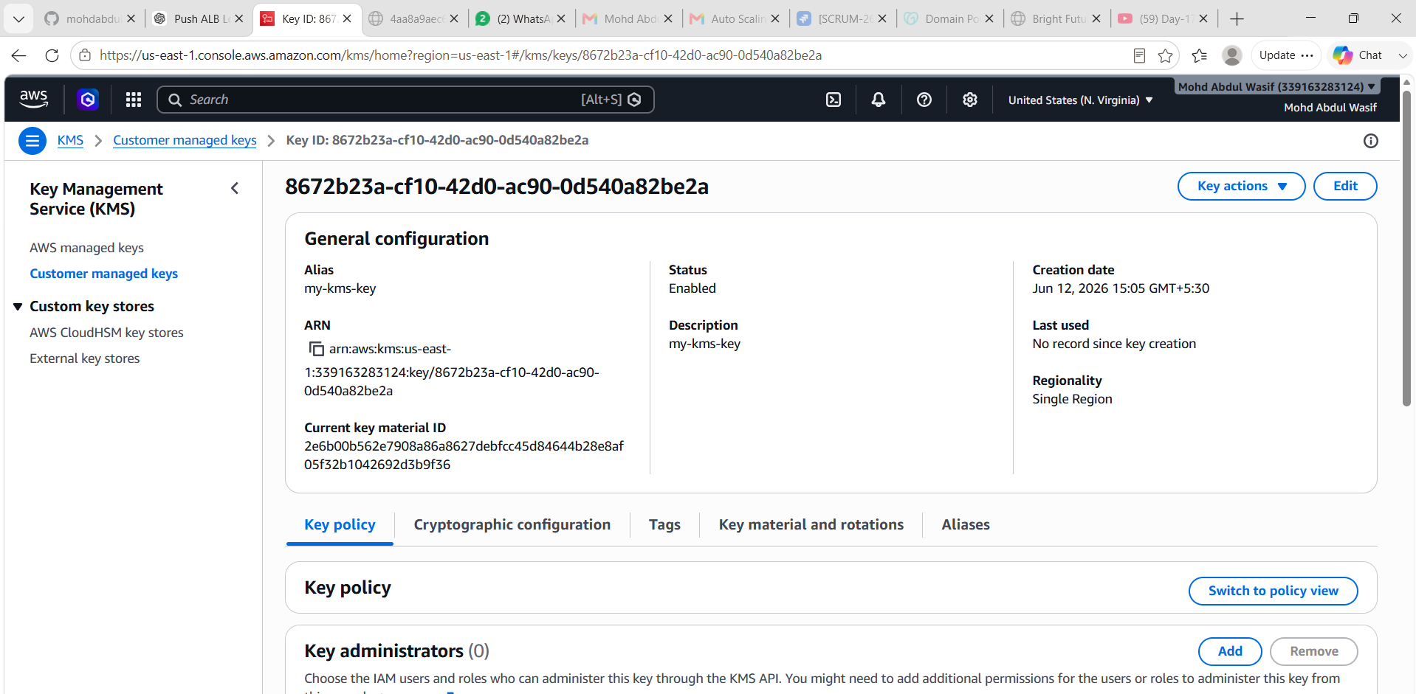

Architecture Diagram
User
|
v
API Gateway
|
v
Lambda Function
|
v
Response
KMS
|
v
Encryption/Decryption

Observations
Lambda
- Serverless compute service.
- Automatically scales.
- No server management required.
API Gateway
- Creates REST APIs.
- Integrates easily with Lambda.
- Secure and scalable.
KMS
- Centralized key management.
- Supports encryption and decryption.
- Integrates with multiple AWS services.

Final Result
Successfully implemented:
✅ AWS Lambda Function
✅ AWS API Gateway Integration
✅ AWS KMS Key Creation and Encryption
✅ Tested end-to-end API flow
✅ Verified encryption and decryption operations
Key Learnings
- Learned how serverless computing works using AWS Lambda.
- Understood API creation and management using API Gateway.
- Learned how API Gateway invokes Lambda functions.
- Understood encryption and key management using AWS KMS.
- Learned how AWS services integrate to build secure and scalable applications.
- Gained hands-on experience with serverless architecture.
- Understood the advantages of managed AWS services over self-managed infrastructure.

Conclusion
Successfully implemented AWS Lambda, API Gateway, and AWS KMS. The Lambda function was deployed and tested successfully, API Gateway exposed the Lambda function through a REST API, and KMS was used to encrypt and decrypt data securely. This exercise provided practical experience in building a secure serverless application architecture on AWS.

